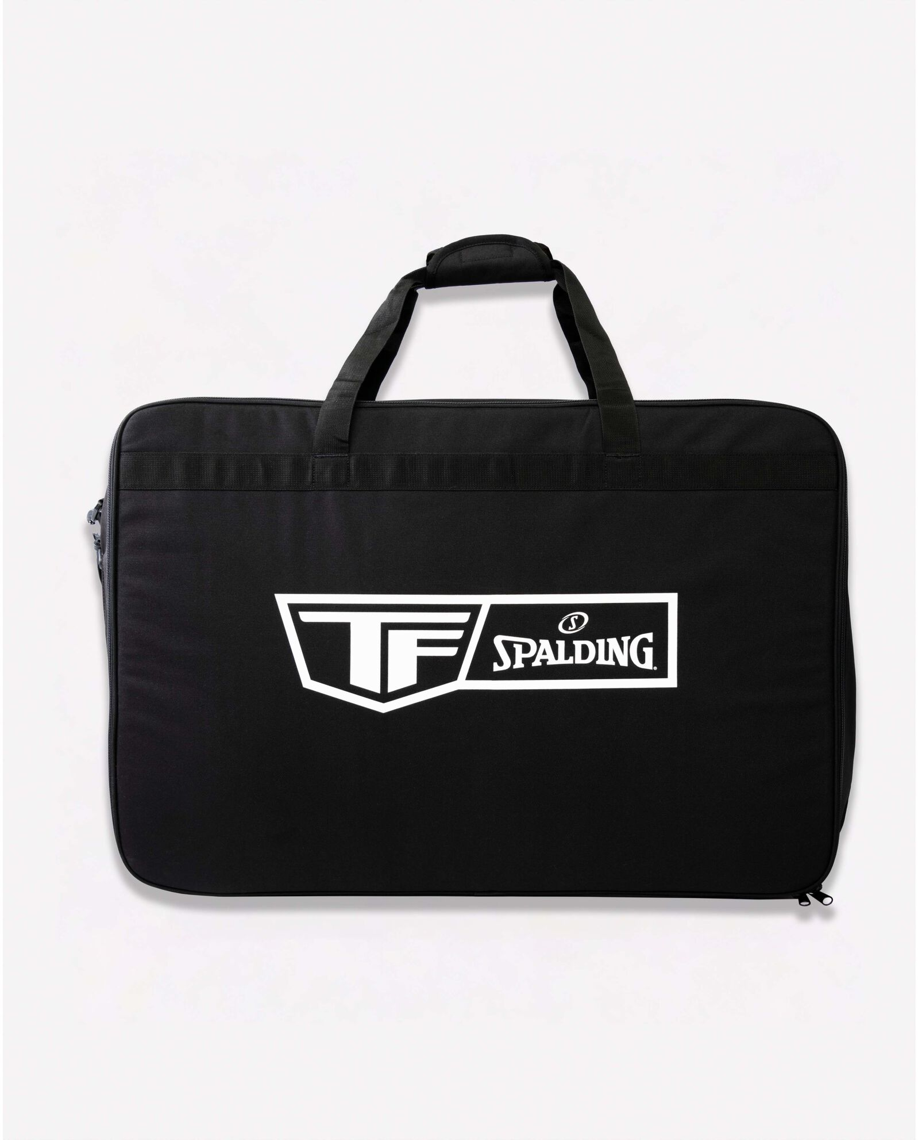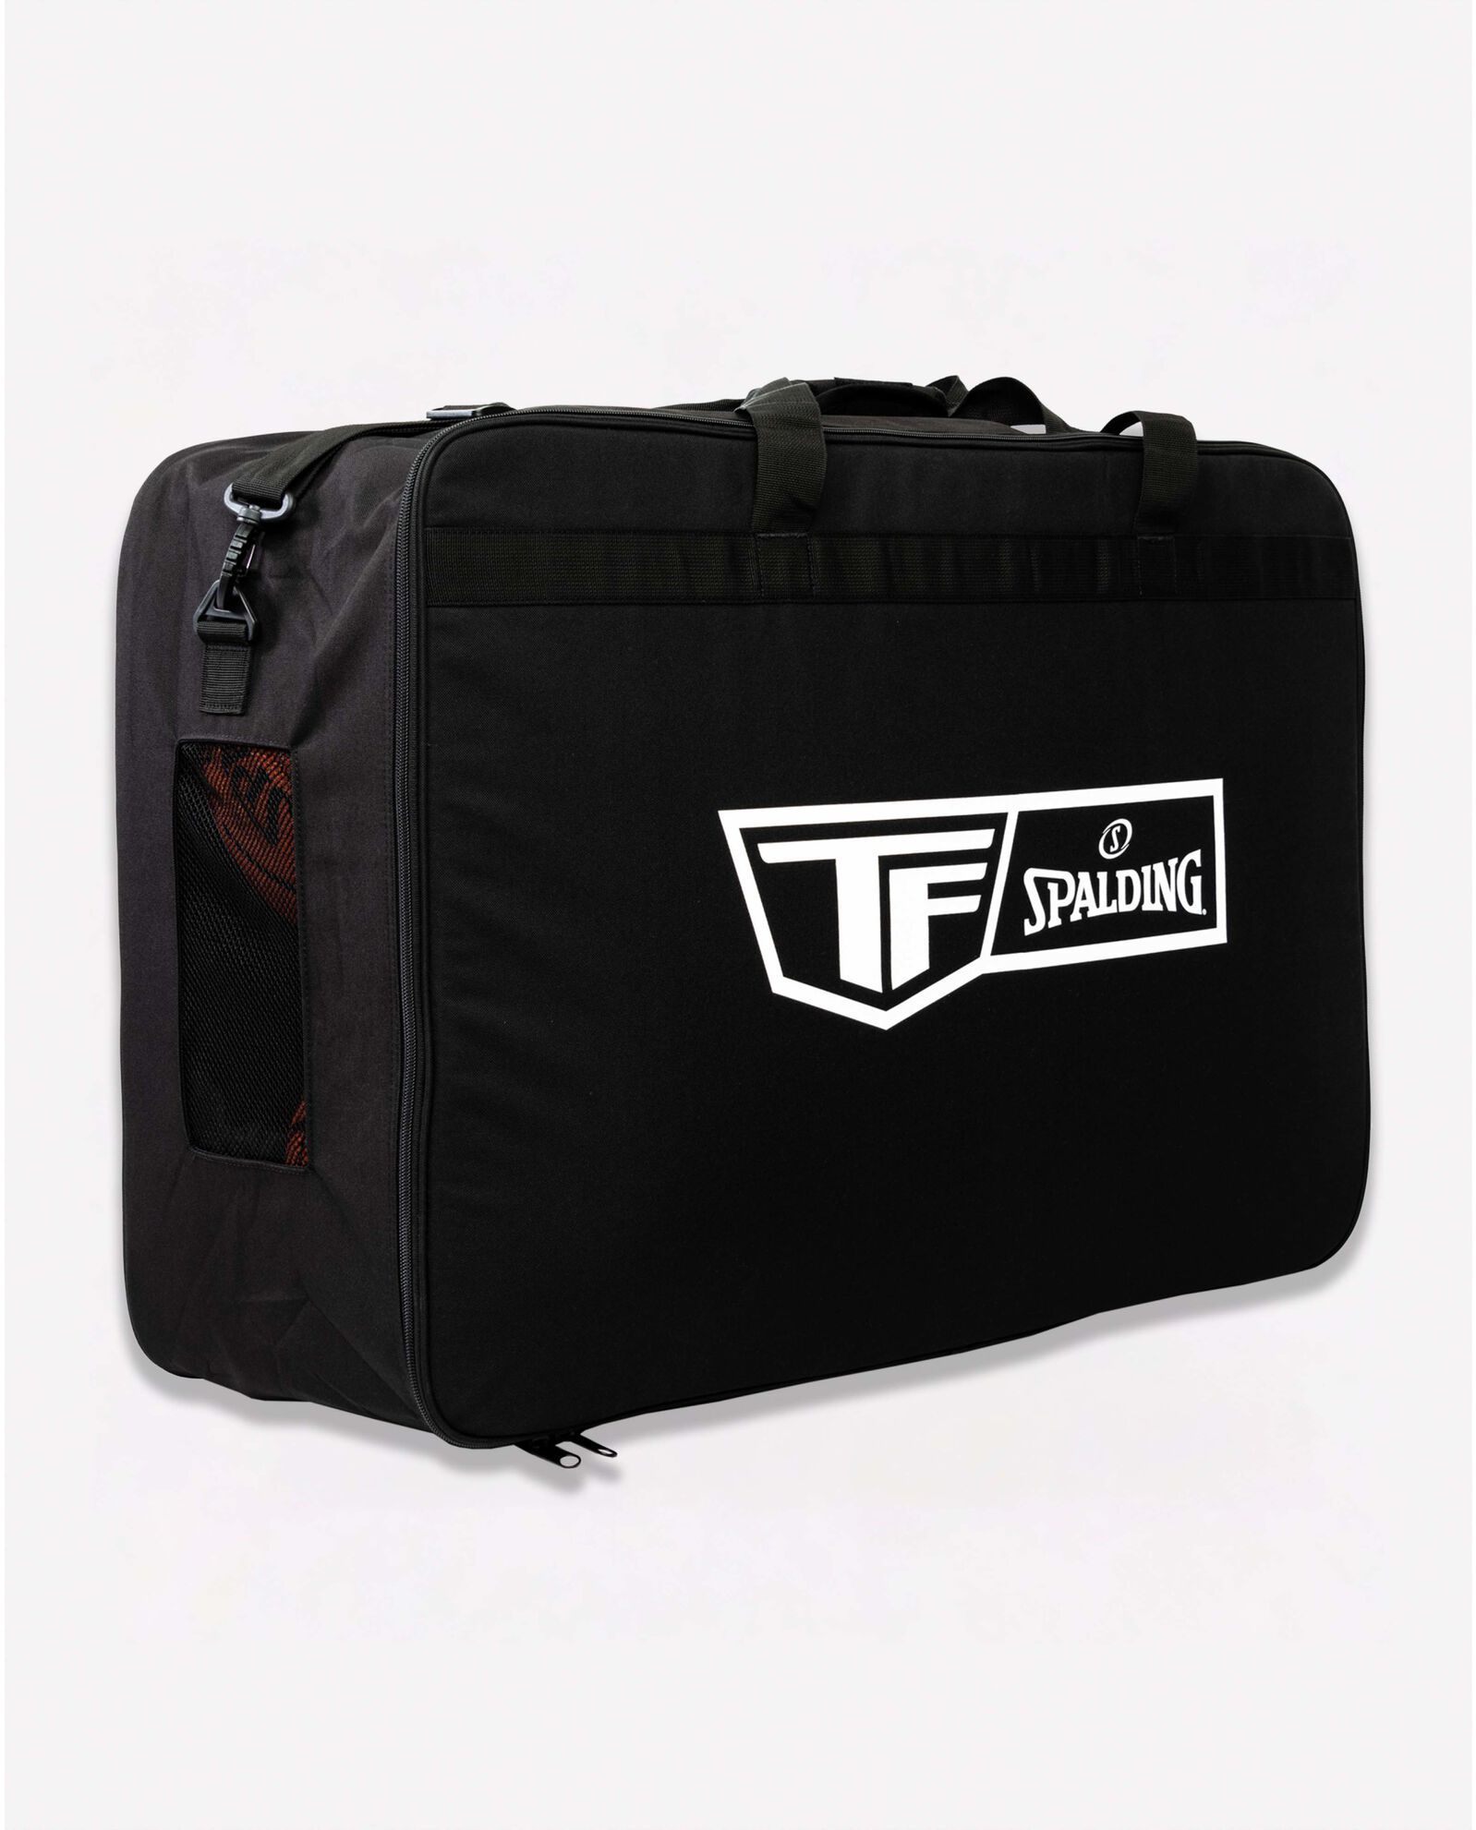

SPALDING TF EQUIPMENT BALL BAG

Travel to and from the gym with all your game and practice necessities. The Spalding TF Equipment Bag is the perfect deluxe bag for transporting up to 6 full-size basketballs and additional equipment, made of high-grade materials for long-lasting use. Its rectangle design makes it easy to carry, and the adjustable shoulder strap and built-in handle make handling a breeze. The addition of open air side vents allows for moisture and odor to escape in-between uses.

**DETAILS:**

* DIMENSIONS: 29.5" x 20" x 9.4"
* HEAVY DUTY: High-Grade Durable Construction for Long Lasting Usage
* BREATHABLE: Open Air Side Vents Allow for Moisture/Odor to Escape
* HANDLING: Comes Equipped with Adjustable/Removable Shoulder Strap and Built-In Handle for Easy Portability
* DESIGN: Rectangle Shape Makes it Easy to Carry with Internal Compartments for 6 Basketballs and Equipment
* Backed by Spalding's Warranty